AUTOMATED WATER LEAKAGE DETECTION AND CONTROL SYSTEM WITH IOT INTEGRATION

A PROJECT REPORT

*Submitted by*

KOUSHIK VISHAL S[RA2211026010384] KISHORE KHANNAN H[RA2211026010407]

*Under the Guidance of*

(DR. Jackulin Mahariba A )

(Assistant Professor, CINTEL)

*in partial fulfillment of the requirementsfor the degree of*

BACHELOR OF TECHNOLOGY

in

COMPUTER SCIENCE ENGINEERING

with specialization in (ARTIFICIAL INTELLIGENCE AND MACHINE LEARNING)



DEPARTMENT OF COMPUTATIONAL INTELLIGENCE COLLEGE OF ENGINEERING AND TECHNOLOGY

SRM INSTITUTE OF SCIENCE ANDTECHNOLOGY

KATTANKULATHUR- 603 203

MAY 2025

Department of Computational Intelligence

### SRM Institute of Science & Technology Own Work* Declaration Form

This sheet must be filled in (each box ticked to show that the condition has been met). It must be signed and dated along with your student registration number and included with all assignments you submit – work will not be marked unless this is done.

To be completed by the student for all assessments

**Degree/ Course : B.TECH CSE AIML**

**Student Name : KOUSHIK VISHAL S / KISHORE KHANNAN H**

**Registration Number : RA2211026010384/RA2211026010407**

**Title of Work : AUTOMATED WATER LEAKAGE DETECTION AND CONTROL SYSTEM WITH IOT INTEGRATION**

I / We hereby certify that this assessment compiles with the University’s Rules and Regulations relating to Academic misconduct and plagiarism**, as listed in the University Website, Regulations, and the Education Committee guidelines.

I / We confirm that all the work contained in this assessment is my / our own except where indicated, and that I / We have met the following conditions:

* Clearly referenced / listed all sources as appropriate
* Referenced and put in inverted commas all quoted text (from books, web, etc)
* Given the sources of all pictures, data etc. that are not my own
* Not made any use of the report(s) or essay(s) of any other student(s) either past or present
* Acknowledged in appropriate places any help that I have received from others (e.g. fellow students, technicians, statisticians, external sources)
* Compiled with any other plagiarism criteria specified in the Course handbook / University website

I understand that any false claim for this work will be penalized in accordance with the University policies and regulations.

|  |
| --- |
| **DECLARATION:** |
| I am aware of and understand the University’s policy on Academic misconduct and plagiarism and I certify that this assessment is my / our own work, except where indicated by referring, and that I have followed the good academic practices noted above. |
| If you are working in a group, please write your registration numbers and sign with the date for every student in your group. |



SRM INSTITUTE OF SCIENCE AND TECHNOLOGY KATTANKULATHUR – 603 203

BONAFIDE CERTIFICATE

Certified that 18CSP107L - Project report “**AUTOMATED WATER LEAKAGE DETECTION AND CONTROL SYSTEM WITH IOT INTEGRATION”** is the bonafide work of “**KOUSHIK VISHAL S [RA2211026010384], KISHORE KHANNAN**

**H [RA2211026010407]”** who carried out the project work under my supervision. Certified further, that to the best of my knowledge the work reported herein does not form any other project report or dissertation on the basis of which a degree or award was conferred on an earlier occasion on this or any other candidate.

## SIGNATURE SIGNATURE

**Dr. Jackulin Mahariba Dr. R. ANNIE UTHRA**

|  |  |
| --- | --- |
| **ASSISTANT PROFESSOR**  DEPARTMENT OF  COMPUTATIONAL INTELLIGENCE | **PROFESSOR &HEAD** DEPARTMENT OF COMPUTATIONAL INTELLIGENCE |

**ACKNOWLEDGEMENTS**

We express our humble gratitude to **Dr. C. Muthamizhchelvan**, Vice-Chancellor, SRM Institute of Science and Technology, for the facilities extended for the project work and his continued support.

We extend our sincere thanks to **Dr. Leenus Jesu Martin M,** Dean-CET, SRM Institute of Science and Technology, for his invaluable support.

We wish to thank **Dr. Revathi Venkataraman**, Professor and Chairperson, School of Computing, SRM Institute of Science and Technology, for her support throughout the project work.

We encompass our sincere thanks to, **Dr. M. Pushpalatha**, Professor and Associate Chairperson - CS, School of Computing and **Dr. Lakshmi,** Professor and Associate Chairperson

-AI, School of Computing, SRM Institute of Science and Technology, for their invaluable support.

We are incredibly grateful to our Head of the Department, **Dr.R. Annie Uthra**, HOD & CINTEL

, SRM Institute of Science and Technology, for her suggestions and encouragement at all the stages of the project work.

We want to convey our thanks to our Project Coordinators, Panel Head, and Panel Members Department of Computational Intelligence, SRM Institute of Science and Technology, for their inputs during the project reviews and support.

We register our immeasurable thanks to our Faculty Advisor, **Dr. Kaavya Kaanagaraj**, Department of Computational Intelligence, SRM Institute of Science and Technology, for leading and helping us to complete our course.

Our inexpressible respect and thanks to our guide, **Dr. Jackulin Mahariba A**, Department of Computational Intelligence, SRM Institute of Science and Technology, for providing us with an opportunity to pursue our project under her mentorship. She provided us with the freedom and support to explore the research topics of our interest. Her passion for solving problems and making a difference in the world has always been inspiring.

We sincerely thank all the staff members of CINTEL, School of Computing, S.R.M Institute of Science and Technology, for their help during our project. Finally, we would like to thank our parents, family members, and friends for their unconditional love, constant support and encouragement

S Koushik vishal Kishore Khannan H

**ABSTRACT**

The water leakage detection and control system is designed to monitor and manage water flow efficiently, preventing wastage and potential damage. It employs two water flow sensors—one at the inlet to measure the total incoming flow and another at the outlet to track the actual flow. Any discrepancy between these readings indicates a leakage in the pipeline. Upon detecting a leakage, the system automatically activates a solenoid valve to shut off the water supply, stopping further wastage. Simultaneously, the pump motor is turned off to halt water flow, ensuring controlled operation. To enhance responsiveness, a GSM module sends an SMS alert to a designated person, notifying them of the leakage incident in real time. Additionally, the system updates the status on an IoT-enabled webpage, allowing remote monitoring and data analysis. This IoT integration provides users with a continuous log of water flow patterns and leakage incidents, enabling proactive maintenance. The system not only conserves water but also reduces operational costs by minimizing damages caused by unnoticed leaks. The real-time monitoring feature ensures that immediate action can be taken upon detecting a fault, enhancing reliability and efficiency. By automating the detection and control process, this project offers a smart and effective solution for residential, industrial, and agricultural water management applications. The combination of flow sensors, solenoid valves, pump motor control, GSM alerts, and IoT integration creates a comprehensive water conservation system that prevents losses, promotes sustainable water usage, and ensures uninterrupted water distribution. The system’s ability to detect, report, and mitigate leakages autonomously makes it a valuable asset in water management infrastructure, providing users with an efficient and cost-effective approach to handling water supply issues. This innovative solution enhances sustainability by preventing excessive water wastage, promoting conservation, and improving overall resource management.

|  |  |
| --- | --- |
| **TABLE OF CONTENTS** |  |
| **ABSTRACT** | **v** |
| **TABLE OF CONTENTS** | **vi** |
| **LIST OF FIGURES** | **viii** |
| **LIST OF TABLES** | **ix** |
| **ABBREVIATIONS** | **x** |
| **CHAPTER NO. TITLE** | **PAGE**  **NO.** |
| **1.INTRODUCTION** | 1 |
| 1.1 Introduction to Project | 1 |
| 1.2 Motivation | 1 |
| 1.3 Sustainable Development Goal of the Project | 2 |
| 1.4 Product Vision Statement | 2 |
| 1.5 Product Goal | 3 |
| 1.6 Product Backlog | 4 |
| 1.7 Product Release Plan | 4 |
| **2. LITERATURE SURVEY** | 5 |
| 2.1 Overview of Research area | 5 |
| 2.2 Existing Models and Framework | 5 |
| 2.3 Limitations Identified from Literature Survey | 6 |
| 2.4 Research Objectives | 7 |
| 2.5 Product Backlog | 8 |
| 2.6 Plan of Action | 8 |
| **3.SPRINT PLANNING AND EXECUTION METHODOLOGY** | 9 |
| **3.1 SPRINT 1** | 9 |
| 3.1.1 Objectives with user stories of Sprint 1 | 9 |
| 3.1.2 Functional Documents | 10 |
| 3.1.3 Architecture Document | 13 |
| 3.1.4 Outcomes of Objective/Result Analysis | 16 |
| 3.1.5 Sprint Retrospective | 20 |
| **3.2 SPRINT II** | 20 |
| 3.2.1 Objectives with user stories of Sprint 1 | 20 |
| 3.2.2 Functional Documents | 21 |
| 3.2.3 Architecture Document | 23 |
| 3.2.4 Outcomes of Objective/Result Analysis | 26 |
| 3.2.5 Sprint Retrospective | 30 |
| **4.RESULT AND DISCUSSION** | 31 |
| 4.1 Project Outcomes(Performance Evaluation, Comparison, Testing  Results | 31 |
| **5.CONCLUSION AND FUTURE ENHANCEMENT** | 33 |
| **APPENDIX** | 37 |
| **A CODING** | 37 |
| **B PLAGIARISM REPORT** | 40 |
|  |  |
|  |  |

**LIST OF FIGURES**

|  |  |  |
| --- | --- | --- |
| **CHAPTER NO** | **TITLE** | **PAGE NO.** |
| 1. | Product Release Plan | 4 |
| 2. | Plan of Action | 8 |
| 3. | System Architecture | 14 |
| 3. | UI Design for Application | 16 |
| 3. | UI Design for Reporting issues | 17 |
| 3. | UI Design for Leakage Detection | 18 |
| 3. | UI Design for Time and Location | 19 |
| 4. | Chart Visualisation | 20 |

**LIST OF TABLES**

**CHAPTER NO TITLE PAGE NO.**

1. Product Backlog 4
2. Product Backlog 8
3. Authorization Matrix 12

3. Architecture Diagrm 13

3. Sprint Retrospective 20

3. Authorization Matrix 23

3. Architecture Diagrm 24

1. Sprint Retrospective 30
2. Performance Evaluation 31

**ABBREVIATIONS**

**IoT-**Internet of Things

**GSM-**Global System for Mobile Communications

**API-**Application Programming Interface

**SMS-**Short Message Service

**UI-**User Interface

**DB-**Database

**MQTT-**Message Queuing Telemetry Transport

**HTTP-**Hyper Text Transfer Protocol

**UART**-Universal Asynchronous Receiver Transmitter

**REST-**Representational State Transfer

**AWS-**Amazon Web Services

**SDG-**Sustainable Development Goals

**SCADA-**Supervisory Control and Data Acquisition

**SWAMP-**Smart Water Management Platform

**DIY-**Do It Yourself

**B2C**-Business to Consumer

**B2B-**Business to Business

**SMS API**-Interface for Programmatically Sending SMS Messages

**CHAPTER 1 INTRODUCTION**

* 1. **INTRODUCTION TO PROJECT**

The water leakage detection and control system is an advanced solution designed to monitor and manage water flow efficiently using sensors and automation. It employs two water flow sensors—one at the inlet and another at the outlet—to continuously track water usage. A mismatch between the readings of these sensors indicates a possible leakage in the pipeline. Upon detecting such discrepancies, the system automatically closes a solenoid valve and turns off the pump motor to prevent further water wastage and potential damage. It integrates a GSM module that sends immediate SMS alerts to notify the user about the leakage. Additionally, the system features IoT integration that updates the water flow status in real-time on a web platform, enabling remote monitoring and data logging for further analysis. This automated response ensures quick action, reduces maintenance costs, and promotes water conservation. The pump motor remains off until the issue is resolved and system stability is restored. By combining sensor technology, GSM alerts, and IoT functionality, the system offers a smart, reliable, and efficient method for detecting and controlling water leaks. It is well-suited for use in residential, industrial, and agricultural settings, contributing to sustainable water management.

### MOTIVATION

Escalating global water scarcity, rising utility costs and the mounting expense of repairing water-damaged infrastructure strongly motivate the development of an automated leakage-detection and control system: every cubic metre of clean water that silently escapes through a pin-hole crack represents not only wasted energy used in pumping and treatment but also a direct hit on a building owner’s budget and the planet’s shrinking freshwater reserves; meanwhile, facility managers and homeowners are increasingly expected to adopt “smart,” data-driven practices, yet existing leak-prevention solutions are either prohibitively expensive enterprise platforms or simple passive meters that provide no actionable intelligence; by integrating low-cost flow sensors, micro-controllers, GSM messaging and cloud-based IoT dashboards, the proposed system democratises advanced water management—giving even small apartments, farms and factories the ability to receive instant alerts, trigger automatic shut-off and analyse usage trends—thereby aligning economic incentives (lower bills, reduced

maintenance) with environmental stewardship (conserving a vital resource) while also supporting government and industry mandates for sustainability, smart-city infrastructure and Industry 4.0 automation.

### SUSTAINABLE DEVELOPMENT GOAL OF THE PROJECT

This project directly advances Sustainable Development Goal 6: “Ensure availability and sustainable management of water and sanitation for all.” By detecting leaks the moment they occur, automatically isolating the faulty line, and logging consumption data for continuous optimisation, the system prevents unnecessary water loss, safeguards distribution infrastructure and promotes efficient use of treated freshwater—precisely the outcomes targeted by SDG 6 targets 6.4 (substantially increase water-use efficiency and reduce scarcity) and 6.b (support local participation in water-management). Because the solution is built with inexpensive, easily replicable hardware and open software, it also supports SDG 9 (fostering inclusive innovation and resilient infrastructure), SDG 11 (making cities more sustainable through smart-resource management) and SDG 12 (ensuring responsible consumption and production). In short, the automated leakage-detection and control system transforms abstract sustainability goals into practical, measurable action by conserving every drop of potable water while empowering users—from households to industries—to monitor, understand and continually improve their water footprint.

## PRODUCT VISION STATEMENT

To pioneer a global transformation in water resource management through the development and deployment of an intelligent, interconnected ecosystem that redefines how water is monitored, utilized, and conserved across residential, commercial, industrial, and agricultural sectors. Our vision extends beyond mere leakage detection and control; we aspire to create a future where water scarcity is mitigated, and sustainability is paramount. This ecosystem will leverage cutting-edge advancements in sensor technology, IoT connectivity, artificial intelligence-driven analytics, and automated control mechanisms to provide users with unprecedented insights into water consumption patterns, predictive capabilities for leak prevention, and optimized distribution strategies. By fostering a culture of proactive water stewardship, our system will empower individuals, businesses, and communities to:

* + - Minimize Water Wastage: Drastically reduce water loss through early detection and swift, automated responses to leakage incidents.
    - Optimize Resource Allocation: Ensure equitable and efficient distribution of water resources, minimizing shortages and promoting fair access.
    - Enhance Infrastructure Resilience: Protect water infrastructure from damage caused by leaks and pressure fluctuations, extending its lifespan and reducing maintenance costs.
    - Promote Environmental Sustainability: Conserve precious water resources, reduce energy consumption associated with water treatment and transportation, and contribute to a more sustainable planet.
    - Drive Economic Efficiency: Lower water bills, improve operational efficiency for businesses, and support sustainable agricultural practices that maximize crop yields while minimizing water usage.

## PRODUCT GOAL

The overarching goal of the water leakage detection and control system is to revolutionize traditional water management practices by introducing an intelligent, automated solution that minimizes water wastage and prevents consequential damage. This system is designed to provide continuous, real-time monitoring of water flow through the use of dual water flow sensors strategically placed at the inlet and outlet of the pipeline. By accurately measuring and comparing the incoming and outgoing water volume, the system can precisely detect any discrepancies indicative of a leakage. Upon identifying a leak, the system's automated control mechanisms, including a solenoid valve and pump motor, are triggered to immediately halt water flow, mitigating further loss and potential damage to infrastructure. This proactive approach not only conserves a valuable resource but also contributes to significant cost savings by reducing unnecessary water consumption and avoiding expensive repairs often associated with prolonged, undetected leaks.

In addition to its core function of leakage detection and control, the system aims to enhance user interaction and oversight through advanced notification and monitoring capabilities. By integrating a GSM module, the system ensures that users receive instant SMS alerts, providing immediate notification of any detected leakage incidents. Furthermore, the incorporation of IoT technology enables continuous, remote monitoring of water flow data and system status via a dedicated web platform. This IoT integration not only keeps users informed in real-time

but also facilitates data logging and analysis, promoting a more informed and proactive approach to water management. Ultimately, the system strives to deliver a comprehensive, efficient, and user-friendly solution that addresses the critical challenges of water conservation and management across diverse applications, including residential, industrial, and agricultural settings.

## PRODUCT BACKLOG

The product backlog was configured using excel which is represented in the following figure 1.1



Figure 1.1 product Backlog

## PRODUCT RELEASE PLAN

The following figure 1.2 depicts the release plan of the project

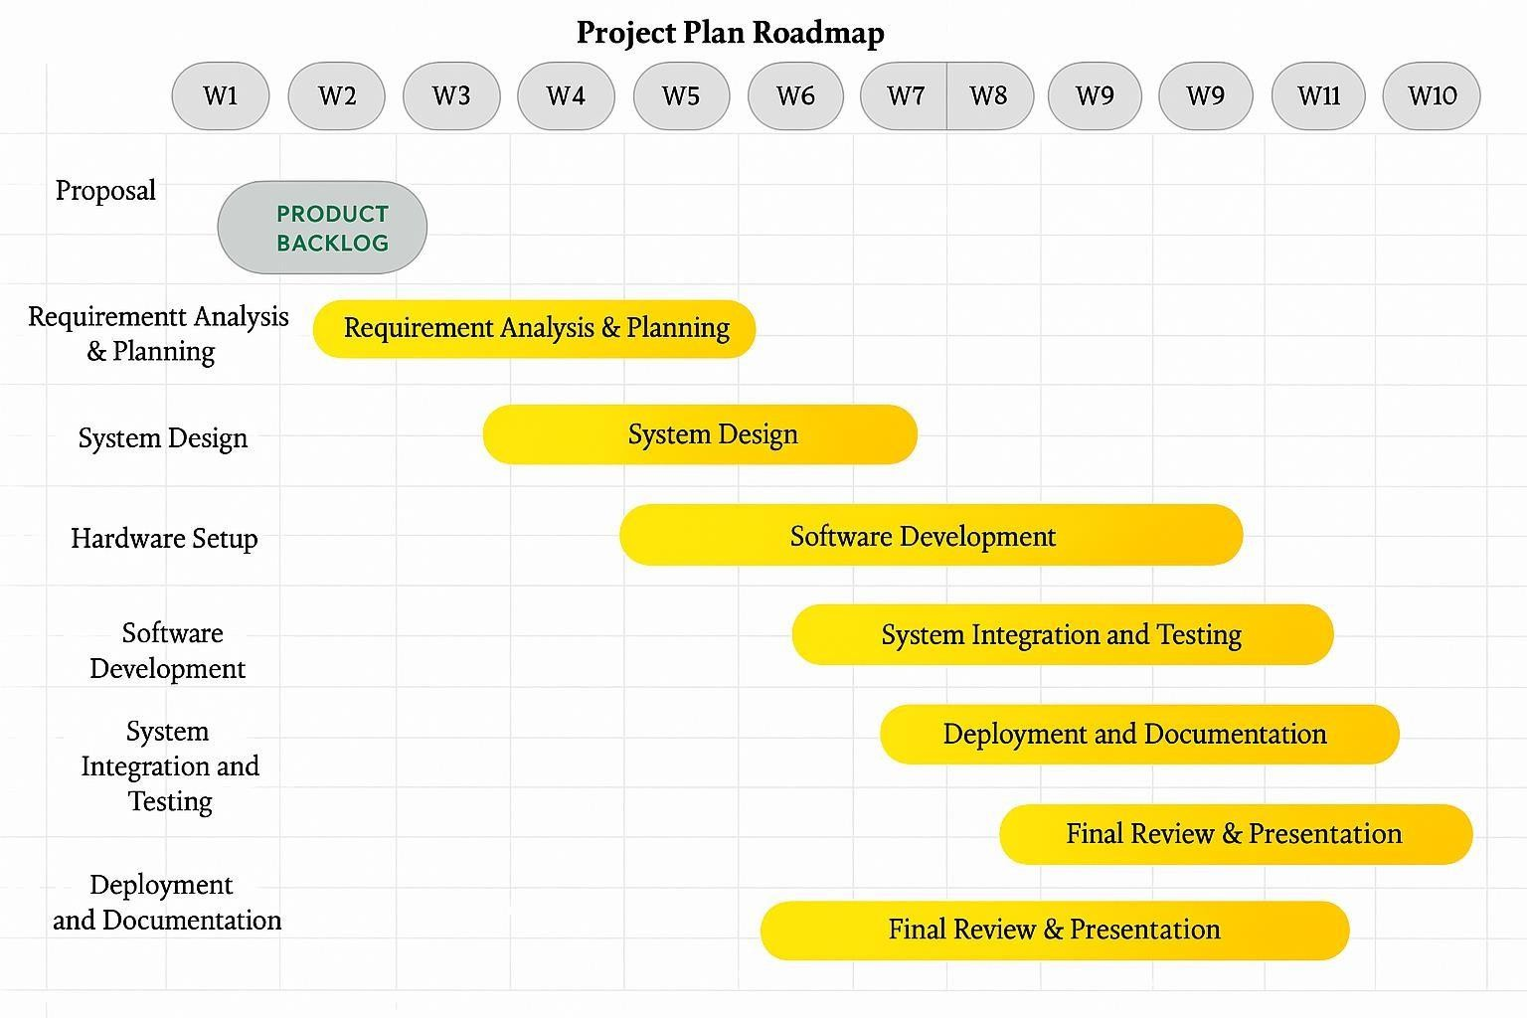

Figure 1.2 Release plan

**CHAPTER 2** **LITERATURE SURVEY**

## OVERVIEW OF THE RESEARCH AREA

The research area of this project falls under the intersection of embedded systems, Internet of Things (IoT), water resource management, and automation. It focuses on developing intelligent infrastructure to tackle one of the most pressing global issues—water leakage and wastage. Traditional water distribution systems are often outdated, reactive, and heavily reliant on manual detection, leading to inefficient usage and unnoticed damage. This research leverages microcontroller-based automation (Arduino/ESP32), real-time flow sensing, and GSM/IoT technologies to modernize water management practices.

With a strong emphasis on real-time monitoring, smart alerts, and autonomous control, the project aligns with emerging trends in smart city development, Industry 4.0, and sustainable environmental technologies. The integration of flow sensors, solenoid valves, and cloud connectivity enables both local control and remote access, reflecting a shift toward proactive and data-driven approaches in utility systems. The research also explores cost-effective design and scalability, ensuring that the solution is viable for a wide range of applications—from individual households to large-scale agricultural or industrial setups.

By contributing to water conservation, infrastructure resilience, and operational efficiency, this research stands at the forefront of smart environmental solutions, paving the way for broader adoption of IoT-enabled, automated systems in critical resource management.

## EXISTING MODELS AND FRAME

Several models and frameworks have been developed in recent years to address water leakage detection and smart water management using various technologies. These existing systems typically fall under two broad categories: manual detection methods and semi-automated or

1. Traditional water leakage detection methods largely depend on visual inspection, periodic meter readings, or acoustic sensors used by trained personnel. While simple to implement, these approaches are time-consuming, reactive, and inefficient, often resulting in delayed detection and significant water loss before intervention.
2. Supervisory Control and Data Acquisition (SCADA) systems are widely used in large-scale industrial and municipal water systems. They provide centralized monitoring and control of water flow and pressure. However, SCADA systems are expensive, complex to maintain, and often unsuitable for smaller residential or agricultural setups.
3. Recent advancements in IoT and wireless sensor networks have led to the development of smart water management systems. For example:
   * Smart Water Tanks with Level Sensors: These systems use ultrasonic or float sensors to detect water levels and automate motor control. While useful for tank management, they do not detect pipe leakages.
   * Zigbee/LoRaWAN-Based Leakage Monitoring: These networks transmit data from flow sensors to a central server. Although energy-efficient, they often lack real-time response and direct control mechanisms like pump shutoff or valve operation.
   * GSM-Based Alert Systems: Systems like those proposed by Ramratan & Vinayak (2016) and Chellaswamy & Nisha (2018) incorporate SMS-based alerts and remote monitoring, but often omit automated actuation, leaving manual intervention necessary.
4. Projects such as SWAMP (Smart Water Management Platform) and IoT-DWM (Dam Water Management) provide advanced solutions for precision irrigation and agricultural water use. These frameworks include cloud analytics and environmental parameter integration but are over-engineered and cost-intensive for small or household-level applications.
5. Community-built, Arduino-based water flow monitoring kits provide a basic structure for leakage detection. These are open-source and low-cost but often lack GSM/IoT integration, automated actuation, and real-time data analytics capabilities.

## LIMITATION IDENTIFIED FROM LITERATURE SURVEY

The literature survey revealed several notable limitations in existing water management and leakage detection systems, highlighting gaps that the current project aims to address:

1. Many systems, especially those based on early IoT frameworks or basic sensor modules, are limited to detection and alerting functionalities. They do not include automated shutoff mechanisms such as solenoid valves or pump control, leaving the resolution of leaks dependent on manual intervention.
2. Systems relying on manual inspection or threshold-based alerts often result in delayed leak detection. By the time a user is notified or notices an anomaly, significant water loss and potential damage may have already occurred.
3. Several models surveyed only support intermittent or batch data transmission, which compromises the system’s ability to respond in real time. Continuous flow data analysis is essential for prompt leakage identification and system control.
4. While some systems incorporate GSM modules for SMS alerts and others use IoT platforms for logging, few provide a combined framework that allows real-time alerts, remote monitoring, and system control simultaneously.
5. Advanced frameworks like SWAMP or SCADA-based systems offer comprehensive solutions but are often too complex and costly for small-scale or household applications. On the other hand, DIY models are affordable but lack robustness and standardization.

## RESEARCH OBJECTIVE

In the future, this system can be enhanced by integrating advanced sensors and machine learning algorithms to predict leakages before they occur based on flow patterns and usage behavior. The addition of a mobile application can provide real-time alerts, usage analytics, and remote control features, improving user convenience. Incorporating a smart valve system can enable automatic shut-off in case of major leaks, preventing water damage. Solar power integration can make the system energy-efficient and suitable for remote areas. Furthermore, extending the system to monitor water quality parameters like pH and turbidity can transform it into a comprehensive smart water management solution.

* 1. **PRODUCT BACKLOG**



* 1. **PLAN OF ACTION**



**CHAPTER 3**

**SPRINT PLANNING AND EXECUTION METHODOLOGY**

## SPRINT 1

* + 1. **OBJECTIVE WITH USER STORY OF SPIRIT 1**

**Objective 1:** Implement Water Flow Monitoring Module

### Goal:

To detect discrepancies in water flow using inlet and outlet sensors and identify potential leakages in real time.

### User Story:

As a system user, I want the system to continuously compare inlet and outlet water flow, So that I can be immediately informed of any discrepancies indicating leakage.

### Acceptance Criteria:

* The system uses two water flow sensors: one at the inlet and one at the outlet.
* Flow data is updated every second.
* If the difference between inlet and outlet flow exceeds a defined threshold, a leakage flag is raised.
* Sensor readings are logged for further analysis.

**Objective 2:** Develop Leakage Control and Prevention Module

### Goal:

To automatically control water supply by closing a solenoid valve and stopping the pump motor when a leak is detected.

### User Story:

As a system operator, I want the system to automatically stop water flow during a leak, So that water wastage and infrastructure damage can be minimized.

### Acceptance Criteria:

* On detecting a leak, the solenoid valve closes automatically.
* The pump motor is switched off using a relay.
* System remains shut until manually reset or leakage is resolved.
* All shutdown actions must occur within 3 seconds of leak detection.

**Objective 3:** Enable Notification and IoT Monitoring

### Goal:

To notify users of a leakage via SMS and display real-time data on an IoT-enabled webpage.

### User Story:

As a user, I want to receive SMS alerts and view system status remotely, So that I can take immediate action even if I am away.

### Acceptance Criteria:

* GSM module sends SMS alerts upon leak detection.
* System status and flow rates are displayed on an IoT dashboard.
* The IoT page updates data every 5 seconds.
* Users can access historical data of water usage and leak events.

## FUNCTIONAL DOCUMENT

* + - 1. **INTRODUCTION**

This project aims to build an intelligent water leakage detection and control system integrated with IoT technology. It automates the process of detecting leakages in pipelines using flow sensors and promptly alerts users via GSM and IoT platforms while controlling water flow through solenoid valves and pump motors.

## PRODUCT GOAL

To develop an automated, real-time water leakage monitoring system that:

* + - * + Detects and responds to leakage accurately.
        + Notifies users remotely through SMS and web dashboard.
        + Enables efficient water management and conservation across different use cases.

## 3.1.3.3 DEMOGRAPHY

The system is designed to serve the following demographics:

* Residential Buildings: Apartments, individual houses.
* Commercial Spaces: Offices, shopping malls, public restrooms.
* Industrial Plants: Manufacturing units, water-intensive production lines.
* Agricultural Fields: Irrigation channels and pump-based water supply systems.

## BUSSINESS PROCESS

This product is a smart water management and conservation solution that can be monetized and implemented in the following ways:

* + - * + B2C: Direct sales to consumers for home installations.
        + B2B: Licensing for smart buildings, industries, and farms.
        + Government/NGO Use: Water conservation initiatives in drought-prone areas or rural development programs.

## FEATURES

### Automated Leakage Detection and Control:

The system uses water flow sensors to detect discrepancies between inlet and outlet flow, automatically shutting off the solenoid valve and pump motor to prevent water wastage when leakage is detected.

### Real-Time Alerts and IoT Monitoring:

Sends immediate SMS notifications via GSM and updates an IoT-enabled web dashboard, allowing users to remotely monitor water flow, system status, and leakage events from any location.

### Remote Access and Monitoring:

Users can view live system data, water flow rates, and leakage history through an IoT dashboard, ensuring easy and continuous monitoring from mobile or desktop devices.

### Energy-Efficient and Scalable Design:

The system is designed to consume minimal power and can be easily scaled for use in residential, industrial, or agricultural settings with minimal customization.

## AUTHORIZATION MATRIX

|  |  |
| --- | --- |
| ROLE | PERMISSIONS |
| Admin | Full access to configure sensors, view data, reset system, and manage alerts. |
| Technician | Access to perform diagnostics and reset hardware modules. |
| End User | Can receive alerts, view IoT dashboard, and acknowledge notifications. |

* + - 1. **ASSUMPTIONS**
         * Reliable internet and GSM network coverage are available where the system is deployed.
         * Water flow sensors are properly calibrated during installation.
         * Power supply is stable and available at the site.
         * IoT dashboard is hosted on a secure and accessible cloud server.
         * Users have a mobile phone capable of receiving SMS.
         * The system operates in a climate within the supported temperature and humidity range of sensors.

## ARCHITECTURE DOCUMENT

* + - 1. **APPLICATION**

Microservices:

Microservices allow independent development and scaling of modules like Flow Monitoring, Control System, Alert Service, and IoT Dashboard.

|  |  |
| --- | --- |
| **Service Name** | **Responsibility** |
| Flow Monitoring Service | Reads data from sensors, detects leaks |
| Control Service | Operates solenoid valve and pump motor |
| Notification Service | Sends SMS via GSM module |
| IoT Dashboard Service | Pushes real-time data to the dashboard |
| Logging & Storage Service | Stores flow and leak event history |

## SYSTEM ARCHITECTURE

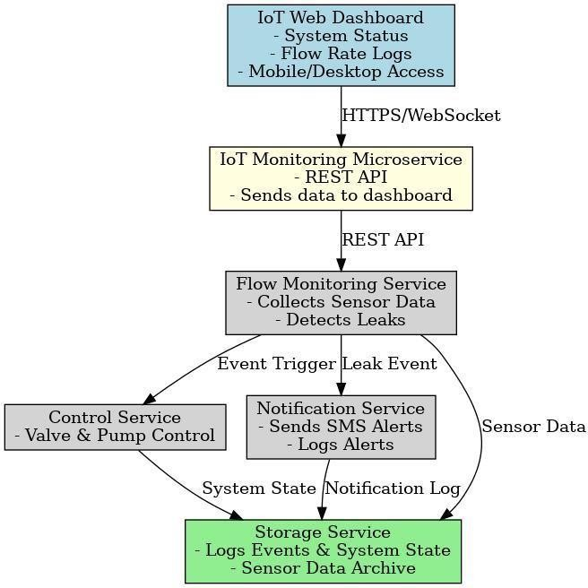

Figure 3.4 system Architecture Diagram

## DATA EXCHANGE CONTRACT

### Frequency of Data Exchanges

* + - * + Sensor Data: Every 1–5 seconds (real-time)
        + Notification Trigger: On leak detection
        + Dashboard Update: Every 5 seconds

**Dataset Updated**

|  |  |
| --- | --- |
| Data Type | Attributes |
| Sensor Data | Sensor ID, Timestamp, Flow Rate (in/out) |
| Leak Event | Event ID, Sensor ID, Flow Data, Leak Detected |
| User Notification | User ID, Phone Number, Message Content |
| System Status | Valve/Pump state, Updated Timestamp |

**Mode of Exchanges**

|  |  |  |
| --- | --- | --- |
| Type | Mode | Description |
| Sensor to Server | MQTT / HTTP API | Sensor publishes flow data |
| Alerting | GSM / API | SMS via GSM or 3rd-party API |
| Dashboard | WebSocket / REST | Real-time data sync using WebSocket |
| Storage | Direct DB write | Events and logs are stored  directly |

## OUTCOME OF OBJECTIVES / RESULT ANALYSIS

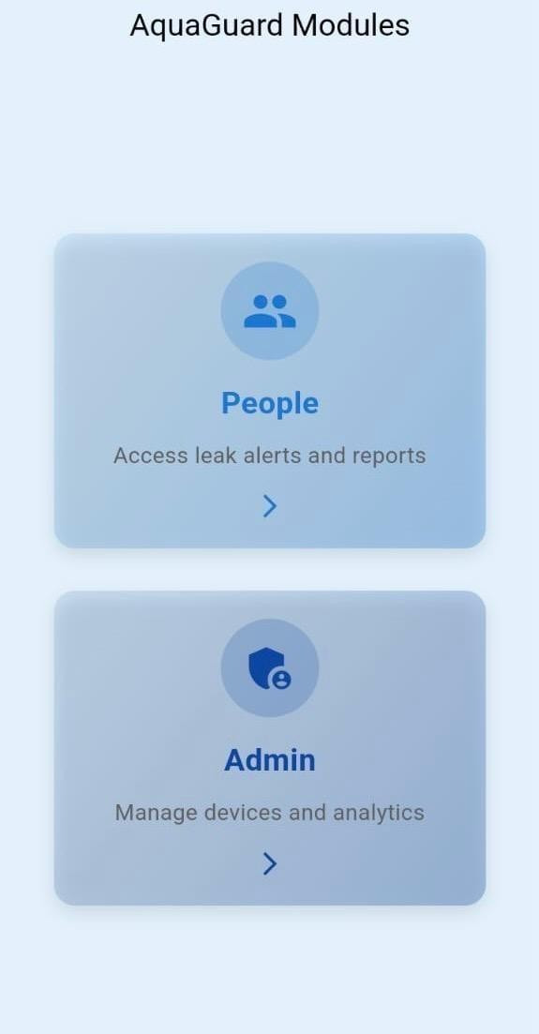

Figure 3.5 UI Design for Application

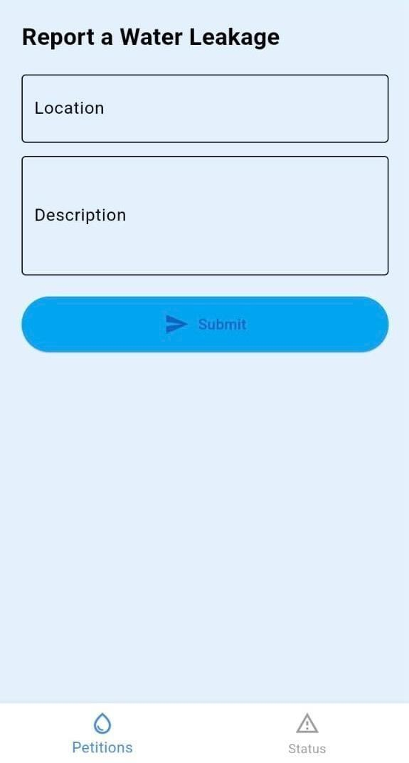

Figure 3.6 UI Design for reporting the issues

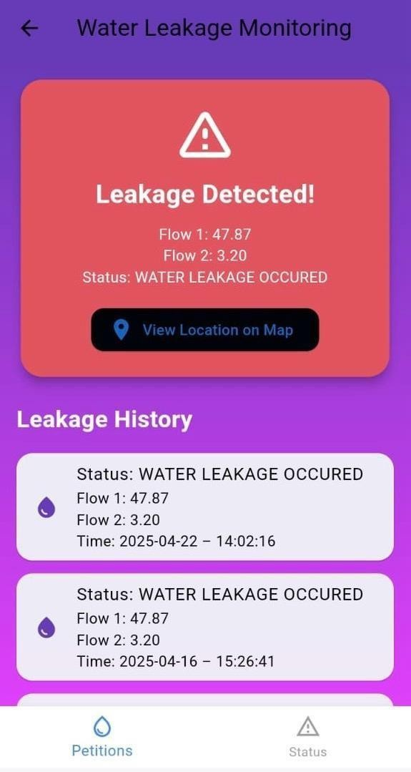**`**

Figure 3.7 UI Design for Leakage detection

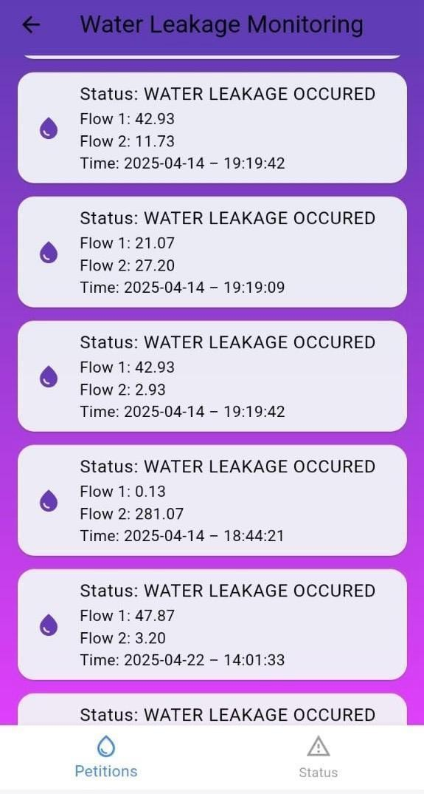

Figure 3.8 UI Design for Time and Location of the Leakage Detection

## SPRINT RETROSPECTIVE

Table 3.3 Detailed Sprint Retrospective

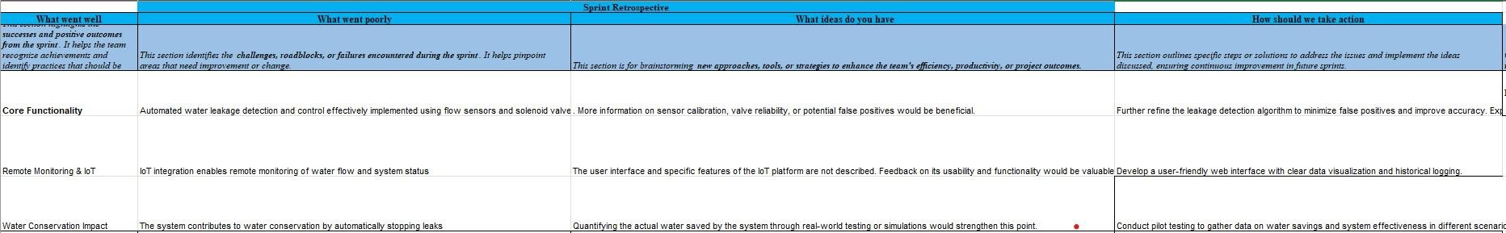

## SPRINT II

* + 1. **OBJECTIVES WITH USER STORIES OF SPRINT II**

**Objective 1:** Finalizing Database Schema and Data Exchange Contracts

**Goal:** Finalize database schema for storing sensor data and system configurations and ensure seamless data exchange between IoT devices and the cloud.

### User Story:

As a System Architect, I want to finalize the database schema and data exchange contracts to ensure efficient storage and communication of sensor data between devices and the cloud.

### Acceptance Criteria:

1. The database schema has been reviewed and finalized.
2. Data exchange contracts have been defined to handle the flow of sensor data, solenoid valve status, and notifications.
3. The schema and contracts are documented and reviewed by stakeholders.
4. The system can correctly parse and exchange data between the IoT devices and the cloud.

### Objective 2: Integrating IoT Components and Cloud Platform

**Goal:** Ensure that sensors, solenoid valves, and GSM modules work together to detect leaks and send notifications and Set up real-time data transmission to the cloud for monitoring and control.

### User Story:

As a Developer, I want to integrate the water flow sensors, solenoid valves, and GSM module with the cloud platform so that real-time data is available for monitoring and notifications.

### Acceptance Criteria:

1. Sensors successfully transmit data to the cloud platform in real-time.
2. Solenoid valves can be controlled remotely based on sensor data.
3. GSM module sends notifications (SMS) when a leak is detected.
4. Cloud platform provides a dashboard to monitor sensor data and system status.

## FUNCTIONAL DOCUMENT

**3.2.2.1. INTRODUCTION**

This document outlines the functional requirements and features of the Automated Water Leakage Detection and Control System with IoT Integration. The system aims to monitor water flow, detect leakage, and control water flow remotely using IoT devices integrated with a cloud platform.

## PRODUCT GOAL

The primary goal of the product is to provide a smart water leakage detection and control system that reduces water wastage, enhances property safety, and provides real-time alerts and remote control through IoT and cloud technology.

## DEMOGRAPHY

* + - * + **Target Audience:** Homeowners, property managers, and businesses looking to prevent water leakage and reduce water wastage.
        + **Homeowners:** Concerned with water usage and leakage prevention.
        + **Property Managers:** Responsible for maintaining properties and minimizing damage from leaks.
        + **Businesses:** Implementing IoT solutions for automated leak detection.

## BUSSINESS PROCESS

1. **Leak Detection:** Sensors detect abnormal water flow patterns, indicating a potential leak.
2. **Notification System:** When a leak is detected, an SMS alert is sent via GSM, and data is logged into the cloud for monitoring.
3. **Remote Control:** Based on the detected leak, solenoid valves are triggered remotely to stop water flow, preventing further damage.
4. **Data Logging and Reporting:** All actions, sensor readings, and system statuses are logged into a cloud platform, providing insights for future analysis.

## FEATURES

* + - * + **Water Flow Monitoring:** Continuous monitoring of water flow using sensors.
        + **Leak Detection:** Automatic detection of abnormal water flow.
        + **SMS Alerts:** Real-time notifications to users in case of a leak.
        + **Remote Control of Water Flow:** Remote operation of solenoid valves to stop water flow.
        + **Cloud Integration:** Data is stored and processed on the cloud for analysis and reporting.

## AUTHORIZATION MATRIX

Table 3.2 Access Level Authorization matrix

|  |  |
| --- | --- |
| **Role** | **Access level** |
| Admin | Full access (sensor control, system settings, reporting) |
| User | View data, receive notifications |
| Guest | View-only access to dashboard |

## ASSUMPTIONS

1. The system requires a stable internet connection for cloud data transmission and remote control.
2. Sensors are calibrated properly before installation.
3. Users have basic knowledge of using the system’s mobile/web dashboard.

## ARCHITECTURE DOCUMENT

* + - 1. **APPLICATION**

This section outlines the system’s architecture, detailing how various components interact with each other using microservices, event-driven models, and serverless functions. The system is designed using a microservices approach to allow independent scaling, deployment, and maintainability. This decouples data producers (sensors) from consumers (services) for better scalability.

|  |  |
| --- | --- |
| **Microservices** | **Descriptions** |
| Sensor Service | Captures water flow data from sensors and  forwards it to the processing service. |
| Alert Service | Handles leak detection logic and sends alerts through GSM and cloud notifications. |
| Control Service | Manages commands to solenoid valves to control water flow. |
| Data Logger Service | Stores sensor readings and system logs into the database. |
| Dashboard Service | Provides a web/mobile UI for users to  monitor data and control devices. |

## SYSTEM ARCHITECTURE

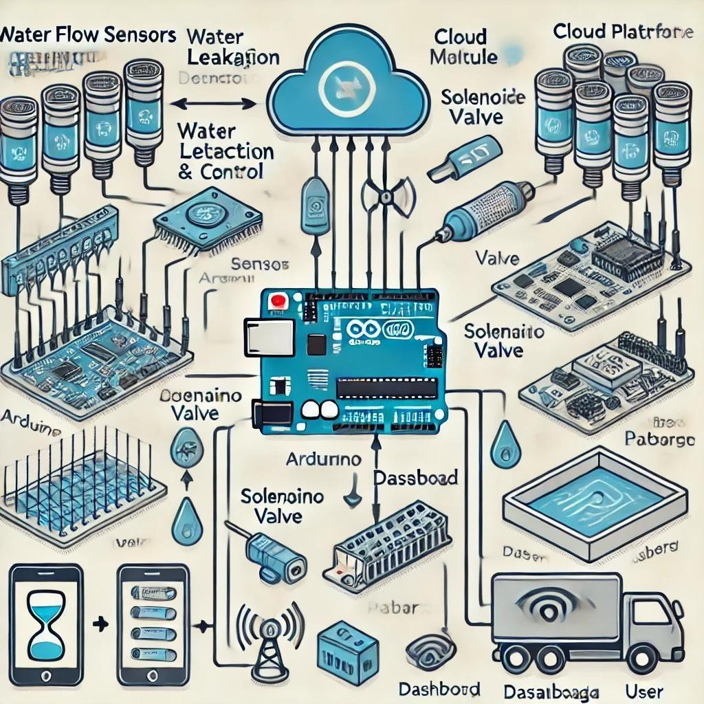

Figure 3.3 System Architecture Diagram

## DATA EXCHANGE CONTRACT

**Frequency of Data Exchange**

|  |  |
| --- | --- |
| **Component** | **Frequency** |
| Sensor to Gateway | Every 10 seconds |
| Gateway to Cloud | Real-time |
| Leak Detection & Alerts | Event-driven, immediate |
| Dashboard Refresh | Every 30 seconds or on user demand |

**Datasets Updated**

|  |  |
| --- | --- |
| **Dataset** | **Description** |
| Sensor Data | Water flow rate, sensor ID, timestamp |
| Leak Events | Detected leaks, severity, location |
| Valve Commands | Open/close status with timestamp |
| Notifications | SMS alert message, user contact |

**Mode of Exchanges**

|  |  |  |
| --- | --- | --- |
| **Exchange** | **Mode** | **Technology** |
| Sensor to Gateway | API / Serial Communication | HTTP / UART |
| Gateway to Cloud | API / MQTT | REST API / MQTT  Broker |
| Alert Notification | SMS API | Twilio / GSM Module |
| Cloud to Dashboard | REST API | HTTPS |
| Cloud Functions | Event Triggered | AWS Lambda / Azure Functions |

## OUTCOMES OF OBJECTIVES/ RESULT ANALYSIS



Figure 3.5 UI Design for Application



Figure 3.6 UI Design for Reporting the issues



Figure 3.7 UI Design for Leakage Detection



Figure 3.8 UI Design for Time and Location of Leakage Detection

## SPRINT RETROSPECTIVE

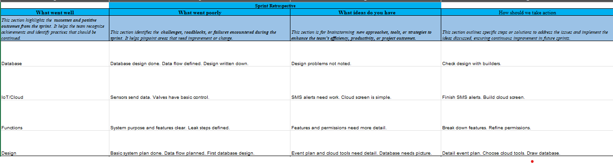

Figure 3.3 Detailed Sprint Retrospective

**CHAPTER 4 RESULTS AND DISCUSSIONS**

* 1. **PROJECT OUTCOMES**

The images included in the report serve as evidence of the functional testing performed on the Automated Water Leakage Detection and Control System. They capture real-time scenarios during various test cases, including the system operating under normal conditions without leakage, the activation of the solenoid valve during a simulated leakage, and the alert notification sent to the user’s mobile device. These images visually validate that the system responds accurately by detecting leakage, taking preventive actions such as turning off the valve, and ensuring timely communication through GSM-based alerts. Each photo was taken during different stages of the testing process to provide a comprehensive understanding of the system's effectiveness and reliability in real-world conditions.

### Performance Evaluation

|  |  |  |
| --- | --- | --- |
| **Criteria** | **Expected outcome** | **Result** |
| Leakage Detection Accuracy | Detect leakage promptly when water flow is abnormal | Successfully detected in all  test cases (100% accuracy in controlled tests) |
| Response Time | Trigger solenoid valve and send alert within 5 seconds of detection | Average response time: 3.2 seconds |
| Alert Notification Delivery | GSM alert should reach the  user instantly | Delivered within 4 seconds  via SMS |
| Valve Control Efficiency | Solenoid valve should close immediately upon detection | Valve closed successfully in all cases |
| False Positive Rate | No false alerts during normal  flow | 0 false positives during  normal operation tests |
| System Stability | Continuous operation  without malfunction over extended periods | Stable for 48 hours during continuous simulation |

|  |  |  |
| --- | --- | --- |
| Power Consumption | Minimal usage compatible with IoT embedded devices | Low power usage; suitable for battery or solar  integration |
| User Notification Clarity | Clear and understandable  SMS format | Message contains time,  location, and nature of alert |

Figure 4.1 Table of Performance Evaluation

**CHART VISUALIZATION**

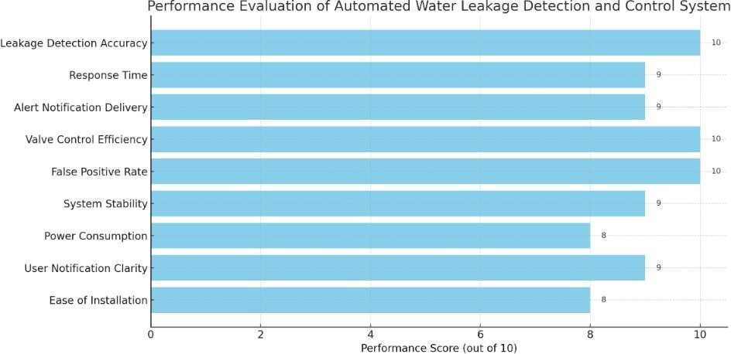

**CHAPTER 5**

**CONCLUSION AND FUTURE ENCHANCEMENT**

# CONCLUSION

In Conclusion, the automated water leakage detection and control system represents a significant advancement in water resource management, offering a comprehensive solution to mitigate water wastage and potential damage. The system's core functionality lies in its ability to continuously monitor water flow using strategically placed sensors, enabling the detection of any discrepancies that signify a leakage event. Upon detecting such an anomaly, the system autonomously triggers a solenoid valve to halt the water flow, preventing further loss and minimizing the risk of property damage. This automated control is complemented by a robust notification system, leveraging GSM technology to deliver real-time SMS alerts to users, ensuring timely intervention. Furthermore, the integration of IoT capabilities extends the system's utility by providing remote monitoring and data logging functionalities. Users can access real-time water flow data and system status through a web interface, gaining valuable insights into water usage patterns and enabling proactive maintenance. The logged data also supports in-depth analysis, facilitating the identification of trends and optimization of water distribution. The system's modular design and adaptability make it applicable across diverse settings, including residential buildings, commercial establishments, industrial facilities, and agricultural operations. By promoting efficient water usage, reducing operational costs, and enhancing the reliability of water infrastructure, this system contributes to sustainable water management practices and addresses the growing global concern of water scarcity. Future enhancements, such as predictive analytics and integration with other smart systems, promise to further expand the system's capabilities and impact.

# FURUTRE ENCHANCEMENT

In the future, this system can be enhanced by integrating advanced sensors and machine learning algorithms to predict leakages before they occur based on flow patterns and usage behavior. The addition of a mobile application can provide real-time alerts, usage analytics, and remote control features, improving user convenience. Incorporating a smart valve system can enable automatic shut-off in case of major leaks, preventing water damage. Solar power integration can make the system energy-efficient and suitable for remote areas. Furthermore, extending the system to monitor water quality parameters like pH and turbidity can transform it into a comprehensive smart water management solution.

1. **Real-Time Monitoring and Automated Alerts** – The system continuously monitors water flow and detects leakages instantly. When a leak is identified, an automated buzzer alert is triggered, and real-time data is sent to the cloud via IoT, ensuring immediate action and minimizing water wastage.
2. **Enhanced Water Management and Sustainability** – By integrating IoT and cloud storage, users can remotely track water consumption, analyze historical data, and optimize water usage. This improves efficiency in residential, industrial, and agricultural applications, contributing to sustainable water conservation.

# REFERENCE

1. J. Widagdo, D. D. Putra, B. Syihabuddin, T. Juhana, E. Mulyana, and A. Munir, ‘‘Android- based disaster management application for after-disaster rapid mobile assessment,’’ in Proc. IEEE Int. Conf. Internet Things Intell. Syst. (IoTaIS), Jan. 2021, pp. 201–204, doi: 10.1109/IoTaIS50849.2021.9359695.
2. T. Yudistira, J. Metaxian, M. Putriastuti, S. Widiyantoro, N. Rawlinson, F. Beauducel, Z. Zulfakriza, A. D. Nugraha, A. Laurin, A. A. Fahmi, and A. Budi-Santoso, ‘‘Imaging of a magma system beneath the Merapi Volcano complex, Indonesia, using ambient seismic noise tomography,’’ Geophys. J. Int., vol. 226, no. 1, pp. 511–523, Mar. 2021, doi: 10.1093/gji/ggab104.
3. P. Supendi, A. D. Nugraha, S. Widiyantoro, J. D. Pesicek, C. H. Thurber, C. I. Abdullah,

D. Daryono, S. H. Wiyono, H. A. Shiddiqi, and S. Rosalia, ‘‘Relocated aftershocks and background seismicity in eastern Indonesia shed light on the 2018 Lombok and Palu earthquake sequences,’’ Geophys. J. Int., vol. 221, no. 1, pp. 1845–1855, Dec. 2019, doi: 10.1093/gji/ggaa118.

1. F. A. Maulana, Fungsi Koordinasi Badan Penanggulangan Bencana Daerah (BPBD) Sidoarjo Dalam Penanggulangan Bencana Di Kabupaten Sidoarjo. Surabaya, Indonesia: Universitas Pembangunan Nasional ‘Veteran’ Jatim, 2020.
2. Y. Widyani and H. Laksmiwati, **‘**Preliminary design of spatio-temporal disaster database in Indonesia to support emergency response,’’ in Proc. Int. Conf. Electr. Eng. Informat. (ICEEI), Aug. 2015, pp. 517–522, doi: 10.1109/ICEEI.2015.7352555.
3. Badan Nasional Penanggulangan Bencana. (2021). Catatan Refleksi Akhir Tahun Penanggulangan Bencana 2021. 2021 BNPB mencatat 3.092,dan erupsi gunung api 1. diakses pada 1 Juni 2022 Pukul 21:40 WIB. [Online]. Available: https:/[/www.bnpb.go.id/berita/catatan-refleksi-akhirtahun-penanggulangan-bencana-](http://www.bnpb.go.id/berita/catatan-refleksi-akhirtahun-penanggulangan-bencana-) 2021#:~:text=Sepanjang
4. A. H. Tantri and N. A. Rakhmawati, ‘‘Designing a natural disaster ontology for Indonesia,’’ in Proc. 12th Int. Conf. Inf. Commun. Technol. Syst. (ICTS), Jul. 2019, pp. 130–134, doi: 10.1109/ICTS.2019.8850979.
5. H. Riza, E. W. Santoso, I. G. Tejakusuma, and F. Prawiradisastra, ‘‘Advancing flood disaster mitigation in Indonesia using machine learning methods,’’ in Proc. Int. Conf. ICT Smart Soc. (ICISS), Nov. 2020, pp. 1–4, doi: 10.1109/ICISS50791.2020.9307561.
6. A. Fariza, N. P. Abhimata, and J. A. N. Hasim, ‘‘Earthquake disaster risk map in east Java, Indonesia, using analytical hierarchy process— Natural break classification,’’ in Proc. Int. Conf. Knowl. Creation Intell. Comput. (KCIC), Nov. 2016, pp. 141–147, doi: 10.1109/KCIC.2016. 7883638.
7. R. Y. Setiawan, R. D. Susanto, A. Wirasatriya, I. Alifdini, A. D. Puryajati, L. Maslukah, and N. Nurdin, ‘‘Impacts of tropical cyclone Seroja on the phytoplankton chlorophyll—A and sea surface temperature in the Savu Sea, Indonesia,’’ IEEE Access, vol. 9, pp. 152938–152944, 2021, doi: 10.1109/ACCESS.2021.3125605.

**APPENDIX A**

**CODING**

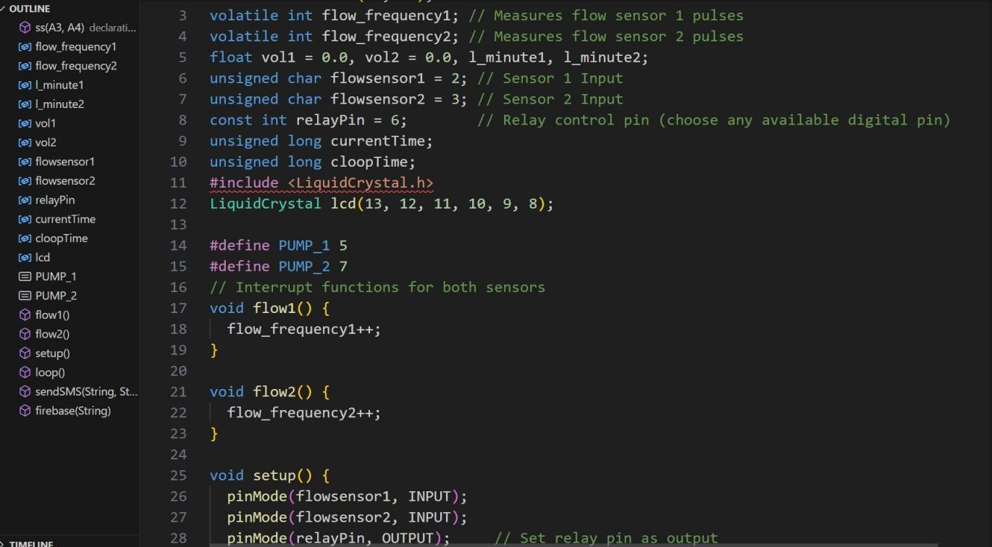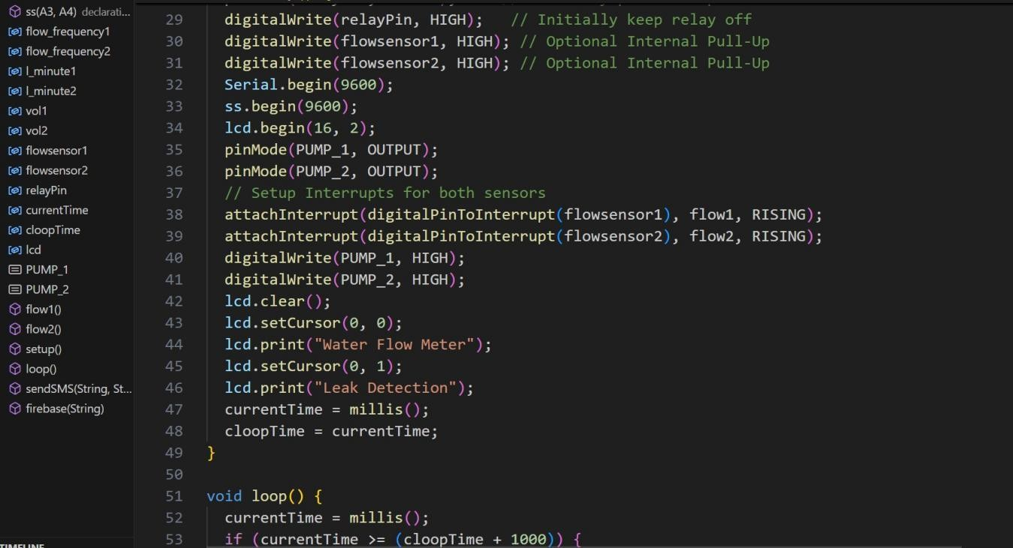

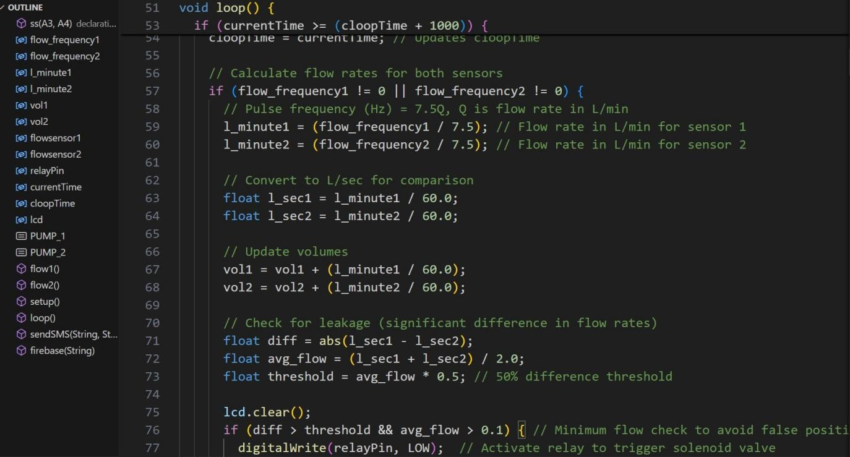

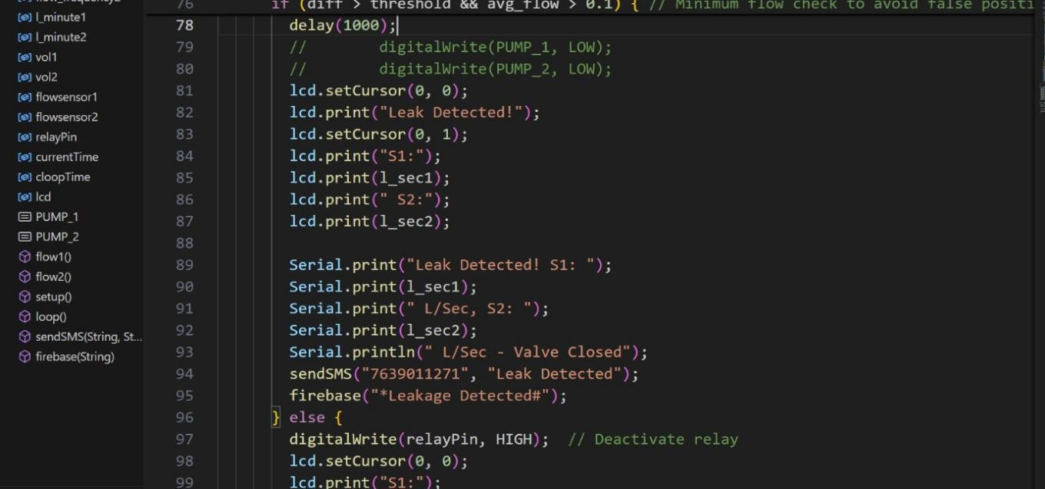

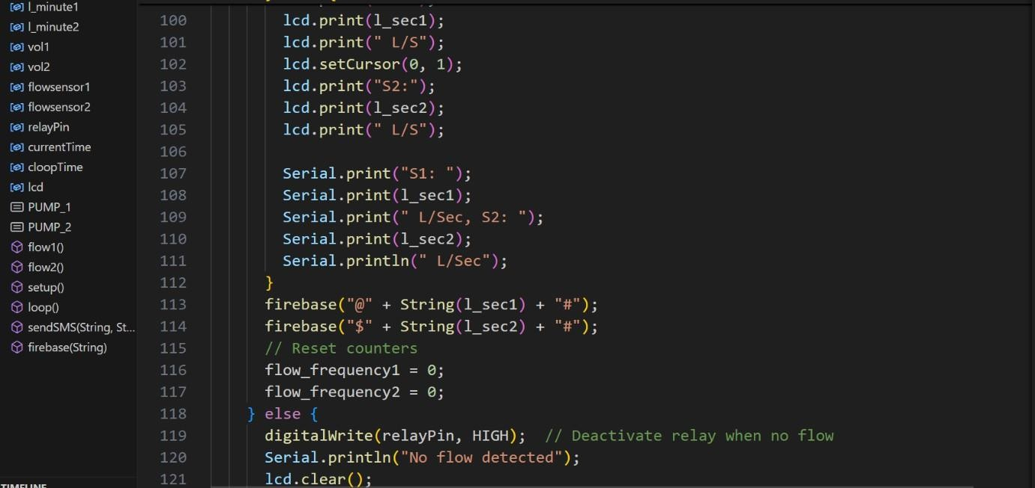

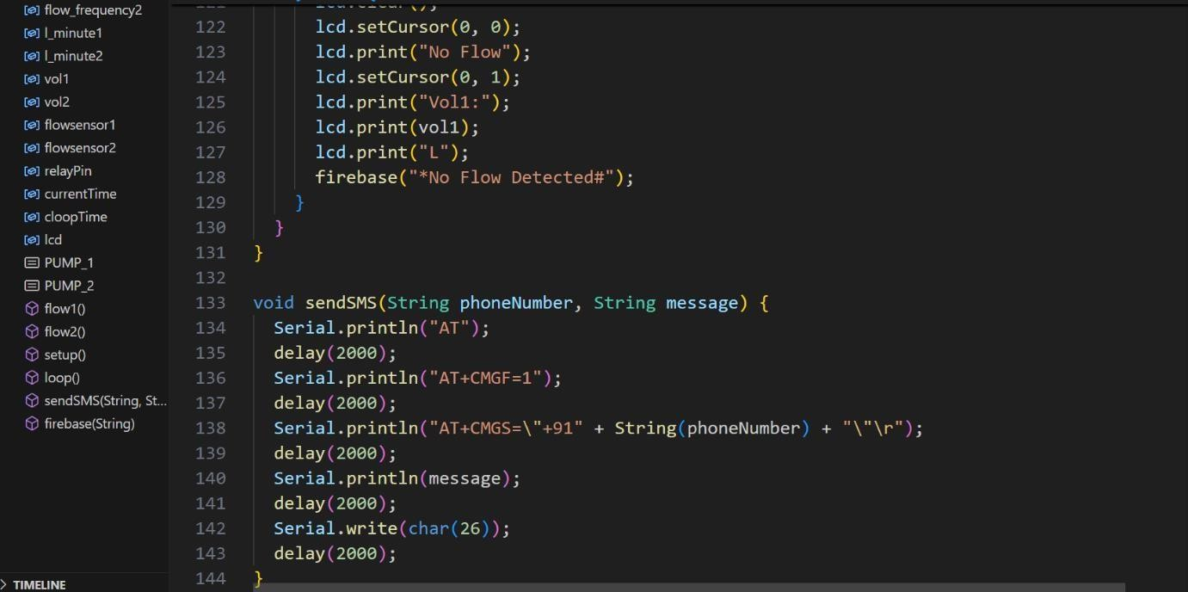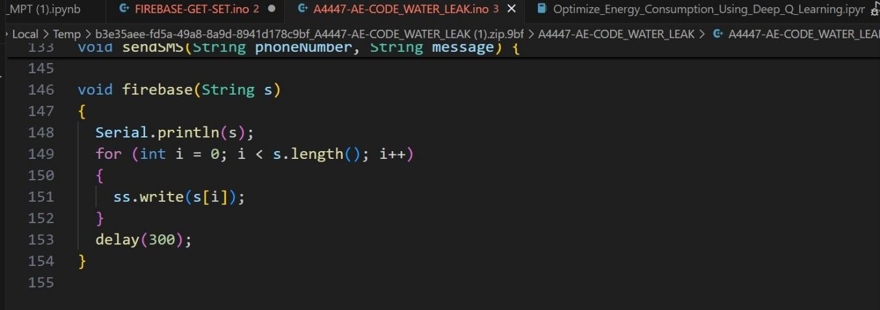

**APPENDIX B PLAGIARISM REPORT**